Impacts of IM and SMS on Communications in the Workplace
Kathleen R. Davenport
Old Dominion University

Abstract
This paper is focused on the effects, both positive and negative, of using instant messaging (IM) and short message service (SMS), more commonly known as text messaging, on communications in the workplace. The impacts of this technology cross many disciplines. For the purposes of this paper, the focus is on business communications, legal, and psychological considerations. The overall conclusion is that IM and SMS technologies enhance the way workers go about their jobs, although it does not necessarily increase the amount of communication taking place in the workplace. This technology has created new liabilities for businesses to be cognizant of, especially the potential of employees having an accident with using a mobile device to conduct business. The use of technology to communicate has made it easier for those who are socially anxious to communicate; while making it difficult to include non-verbal cues into communication.

Impacts of IM and SMS on Communications in the Workplace

Introduction
The majority of people who work in business offices today are used to using face-to-face, telephone, and e-mail for their business communications. They’ve mastered the accepted etiquette and best practices for each means of communication, such as appropriate conduct in meeting rooms, how to leave effective phone messages, and how to structure e-mails, depending on the desired outcome, as well as which means of communications is best used for different circumstances. Technological advances have made e-mail systems commonplace in businesses, large and small. Technology has also introduced instant messaging (IM) and text messaging, often referred to as short message service (SMS), to the workplace. They have been used extensively for some time in informal, personal communications. Instant messaging tools are becoming more prolific in large enterprises. In his review of instant messaging tools designed for business use, Don Reisinger of Information Week says, “Instant messaging has all but replaced the phone as an office tool.” In addition to instant messaging, the use of smart phones, such as BlackBerries, iPhones, and Androids, is also becoming more widely used in businesses. This adds the ability to send messages through mobile devices whether one is in the office or not.
The use of technology has changed the face of business communications. E-mail made communications faster than paper memos and letters. Now, IM and SMS provide immediate access to people, even those who are not co-located. Just as protocols had to be established for e-mail use, businesses will need to consider how best to leverage all computer-mediated communication (CMC) for positive outcomes. Just a few areas that will need to be considered as policies for the use of these tools are being developed are:
- Effects on business communications
- Legal policies and liabilities
- Psychological impacts on workers

Business Communications
Businesses need to be aware of the limitations of IM and SMS as primary communication tools. Effective communications typically includes both verbal and non-verbal cues. IM and SMS lack the ability to effectively communicate non-verbally. Voice inflections, facial expressions and body language do not come across in CMC environments. People may try to provide non-verbal cues with the use of emoticons, such as a smiley face to indicate happiness, but that has limited effectiveness. Mackiewicz and Lam (2009) point out another shortcoming of communicating through IM as confusion over who has the floor in the electronic conversation. In face-to-face conversations, “one person contributes, taking and subsequently holding the floor for the duration of his or her turn” (p. 423) and then turns control of the floor over to the next person in the conversation. This happens seamlessly in face-to-face conversation; however, when using IM or SMS it is no longer clear which of the parties has the floor at any point in time. Mackiewicz and Lam (2009) shared an example of how “short, rapidly sent transmissions” allow the sender to “maintain the floor” (p. 428). This can also lead to confusion as the recipient may be responding to the first message, while the sender is still sending additional messages.
Mackiewicz and Lam (2009) also found IM users were less likely to use polite terms, such as phrasing a direction as a question instead of a command and that those in a position of power were more likely to be more direct than polite (p. 426). Users of IM and SMS need to be diligent in ensuring their communications are being received as they intended by being cognizant of their tone and being explicit in their responses.
Despite the limitations inherent in the use of IM and SMS, there are many advantages to integrating IM and SMS into business communications. Some may consider the ping from an IM or SMS as an interruption to normal work. Garrett & Danziger (2008) studied the disruptive nature of IM in the workplace and found it to be more of an aid to communications than a hindrance. “IM is interruptive by definition” (p. 24); but is it a disruption? Their study concluded that IM “is not as distracting as an inopportune telephone call or an unexpected office visit” (p. 26). Through IM and SMS, a user can postpone answering a colleagues request to a more opportune time in the day. By their nature IM and SMS are intended to be short in nature. A person may be able to obtain a quick answer to a question through IM or SMS and then continue on with the task at hand.
Interruptions are a normal part of the day for office workers and may come in the form of direction from supervisors, requests for information from colleagues, or a colleague wanting to share some office gossip. These interruptions may be in person (someone stopping by the office), by telephone, or through CMC (e-mail, IM, or SMS). Garrett & Danziger (2008) surveyed full-time workers in jobs requiring computer use to determine the level of interruption from IM. They compared the responses of non-IM users with those of IM users. As shown in Figure 1, more non-IM users strongly agreed with the statement, “I rarely complete a work task without being interrupted” (p. 31), indicating that IM users may be better able to manage interruptions. If a worker needs to obtain some bit of information to complete a task, she may use IM to ask a colleague for that information and obtain her answer quicker than if she had phoned, e-mailed or physically gone to ask the colleague face-to-face, thereby saving both workers time. If the request is more complex, both people, using IM, can coordinate the expected time to have that information available.
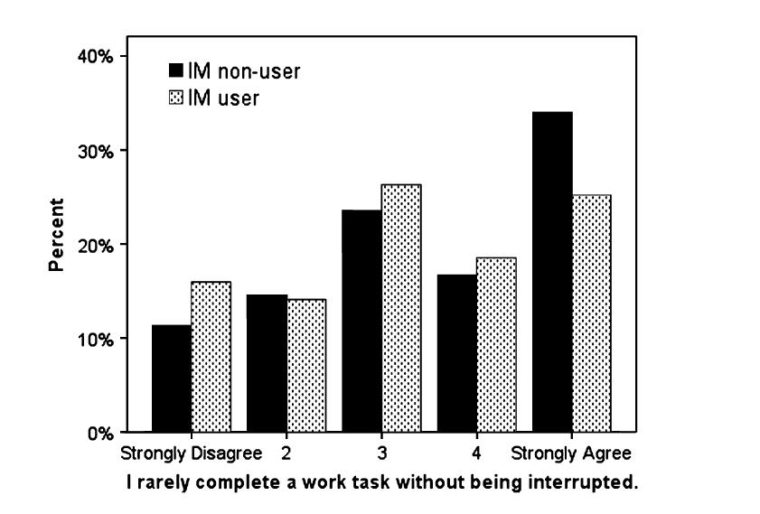
Figure 1. Distribution of interruption, by IM use. (Garrett & Danziger 2008, p. 31)
IM users can control their availability to their colleagues. IM systems allow users to set their status as available or away and even provide additional information, such as when the user expects to return. Some allow the user to block incoming messages, essentially hanging a Do Not Disturb sign on his virtual office. By utilizing these functions within the IM system, workers can manage the level of interruption in their workdays.
IM and SMS can both hinder and enhance business communications, but does it increase or decrease the amount of communication within an organization? In their survey, Garrett & Danziger (2008) asked participants to respond to the statement, “I have shared work knowledge and experiences with coworkers” (p. 33) in an attempt to determine if there is a difference in the amount of communication between the two groups – IM users and non-IM users. Figure 2 shows that over 60 percent of each group responded that they strongly agree with that statement, indicating that about the same amount of workplace communication happens whether the worker uses IM or not.
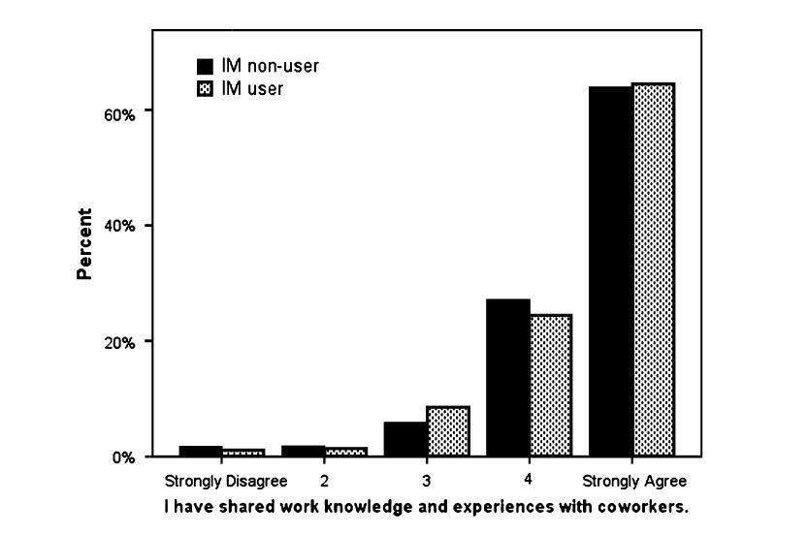
Figure 2. Amount of information exchanged with coworkers, by IM use (Garrett & Danziger 2008, p.33)
Their study concluded that “instant messaging in the workplace simultaneously promotes more frequent communications and reduces interruptions” (p. 38) and that “workers are developing effective strategies for using IM technologies in positive ways” (p. 39). If the communication is simple and all parties are available, IM and SMS are now invaluable tools in enhancing workplace communication. Users should recognize the shortcomings, such as the lack of nonverbal cues, and work to overcome them with more careful use of language. Businesses and workers will need to recognize when an IM or SMS is appropriate to the situation and when other means of communication would be better.

Legal Considerations
When the use of e-mail became commonplace in businesses, those businesses needed to develop policies outlining how their employees could use the company owned e-mail system. Some explicitly forbid employees from using the company’s e-mail system for personal use and still others warn employees that their e-mails are subject to audit. When the company’s policy is clearly written and evenly enforced, the courts have upheld the company’s right to review the content of its employees’ e-mails.
Just as the widespread use of e-mail prompted businesses to develop policies about the use of corporate e-mail, the increased use of IM and SMS in the conduct of business is now driving companies to create policies about their use. Businesses need to clearly communicate to their employees about their policies on privacy of IM and SMS content sent from company owned devices and software. In an interview with Managing People at Work (2010), Paul Lopez, an attorney with Tripp Scott advises, “A written policy is important. But you must also enforce it consistently and not deviate from it” (p. 5).
One example of this type of policy was upheld by the U.S. Supreme Court in City of Ontario v. Jeff Quon. In this case, Jeff Quon was employed as a police officer for the City of Ontario in California. He was issued a pager with SMS capability by his employer. After he exceeded the monthly limit for text messages, the content of his messages was audited. Among over 25,000 messages, there were “456 personal messages, including some sexually explicit ones” (Kirby 2010, p. 32). Quon contended that his Fourth Amendment rights were violated when his messages were audited. With its decision, the U.S. Supreme Court “reaffirmed the power of having clear policies in place in the workplace that address employees’ expectations of privacy” (Law Office Management & Administration Report 2010, p. 8). The City of Ontario had a policy in place stating they had the right to monitor messages sent through the department-provided pager and Quon had signed an acknowledgement of that right. This case emphasizes the need for businesses to be very clear about their policies and consistent in how they enforce them.
A new liability for businesses is emerging from the use mobile devices for IM and SMS. To minimize the legal liabilities for employers, it is imperative that they have clear policies in place which ban employees from conducting business on their mobile devices while driving. Joshua Bonn, an attorney, cautions that “business owners should be aware they can be found liable, under limited circumstances, for damages resulting from an accident caused by an employee who is texting while driving” (Bonn 2009). He goes on to advise businesses to consistently enforce their policies. A study found that “text messaging is 23 times as dangerous” as non-distracted driving (Hofmann 2009, p. 1). More and more states are passing legislation that ban texting while driving. If employers do not take steps to communicate and enforce their policies against using mobile devices while driving, they will face liabilities for accidents which may occur as a result.

Psychological Considerations
As stated earlier, workers may choose IM or SMS when it is the most appropriate form of communication for the situation. The use of this relatively impersonal means of communication is bound to affect how workers relate to one another. It may also make it easier for some individuals to communicate, as compared to face-to-face communications. In their study, Reid and Reid (2007) examined the personal reasons for why individuals would choose to use SMS instead of talking on their cell phones. They found that socially anxious individuals generally preferred to text rather than talk on the phone. According to Bardi and Brady, “IM may reduce anxiety and allow shy persons to initiate more in-depth and more revealing conversations” (2010). In the past, a shy or socially anxious person may have difficulties communicating in the workplace, when communication was primarily face-to-face. Now, these individuals can more effectively communicate through the use of IM and SMS. Reid and Reid concluded that messaging is still a “one-to-one, personalized, and individuating social medium” (p. 434).
A large part of workplace communication is based on the relationships established among workers. In his study about interpersonal relationships and electronic communications, Nie (2001) concludes that “written communication is not equivalent to face-to-face interaction” (p. 432). With the lack of non-verbal cues, recipients of messages will interpret them within the context of their relationship with the sender. Krakovsky (2004) cited Janice Nadler, a social psychologist and law professor, who “says the missing element in electronic communication is rapport” (p. 15). Nadler studied the effects of initiating contact first by phone, and followed with electronic communications compared to transactions that were handled solely through electronic communication. She found that in situations where phone contact was made in the beginning of a negotiation, the parties were four times more likely to reach an agreement. Nadler concludes that a conversation is needed to establish rapport in a business relationship. Krakovsky goes on to advise that if worried that “nuance will be lost in the electronic word” (p. 16), then a phone call would be in order.
The use of IM and SMS allows workers who are less comfortable with face-to-face or phone conversations to still communicate with their colleagues. The use of this technology can help some workers succeed in the workplace where they may not have in the past; however, the relationship building of face-to-face or phone conversations is still considered an important part of business communications.

Conclusion
IM and SMS are becoming more and more commonplace in today’s business environment. Instead of being limited to face-to-face, phone and e-mail communications, this technology is providing workers with more choices in how they communicate during their work day. This also adds an additional burden to choose the right means of communication for the situation. IM and SMS lend themselves to relatively short and simple communications; while e-mail provides an electronic means of communicating more complex requests and explanations. When used effectively, IM and SMS can increase the productivity of today’s workforce and help socially anxious workers to communicate with their colleagues.
It is critical that businesses set out clear policies for the use of devices and applications provided to the employees and what expectations of privacy employees should expect when using those devices and applications. In addition these policies should take into account the potential legal liabilities for the business if an employee should have an accident while conducting business through a mobile device, and set policies to minimize those risks, such as forbidding the use of mobile devices to conduct company business while driving.
There are additional questions yet to be answered on this subject. Garrett & Danziger (2008) posed the question, “What will happen to interruption levels if voice/video-enabled IM clients replace text-based IM in the workplace over the next few years?” (p. 37). The more businesses integrate voice and video in electronic communication, the closer electronic communications come to simulating face-to-face conversations, which take more time to conduct than simple IM or SMS; however, the use of voice and video gives the advantage of more non-verbal cues in the conversation. Will the next generation of workers, who grew up with IM and SMS as a normal means of communication, become more socially anxious when dealing with face-to-face or phone conversations? Today’s older workers learned to conduct business primarily through face-to-face communication and have had to adapt to using IM and SMS, so are still very comfortable in situations which require personal interactions.
References
Barti, C.A. & Brady, M.F. (2010). Why shy people use instant messaging: Loneliness and other motives. Computers in Human Behavior, 26, 1722-1726. doi:10:1016/j.chb.2010.06.021
Bonn, J. D. (2009). Address liability of workers texting while driving. Central Penn Business Journal, 25(48), 12-13. Retrieved from EBSCOhost.
COURT SAYS EMPLOYERS MAY AUDIT TEXTING. (2010). Law Office Management & Administration Report, 10(12), 8. Retrieved from EBSCOhost.
E-mail, texting and privacy. (2010). Managing People at Work, (341), 5. Retrieved from EBSCOhost.
Garrett, R., & Danziger, J. N. (2007). IM = Interruption Management? Instant Messaging and Disruption in the Workplace. Journal of Computer-Mediated Communication, 13(1), 23- 42. doi:10.1111/j.1083-6101.2007.00384.x
Hofmann, M. A. (2009). Multitasking by drivers raises liability concerns. Business Insurance, 43(29), 4-7. Retrieved from EBSCOhost.
Kirby, P. (2010). High Court Justices Skeptical of Privacy in Texting Case. Telecommunications Reports, 76 (9), 32-34.
Krakovsky, M. (2004). CAVEAT SENDER. Psychology Today, 37(2), 15-16. Retrieved from EBSCOhost.
Mackiewicz, J., & Lam, C. (2009). Coherence in Workplace Instant Messages. Journal of Technical Writing & Communication, 39(4), 417-431. doi:10.2190/TW.39.4.e
Nie., N.H. (2001). Sociability, interpersonal relations, and the Internet: Reconciling conflicting findings. The American Behavioral Scientist, 45(3), 420-535. Retrieved March 14, 2011, from ABI/INFORM Global. (Document ID: 84499930).
Reid, D. J., & Reid, F. M. (2007). Text or Talk? Social Anxiety, Loneliness, and Divergent Preferences for Cell Phone Use. CyberPsychology & Behavior, 10(3), 424-435. doi:10.1089/cpb.2006.9936
Reisinger, D. (2009, February 23). Beyond AIM: Top instant messaging clients for business. Information Week. Retrieved from http://www.informationweek.com/story/showArticle.jhtml?articleID=214501080

